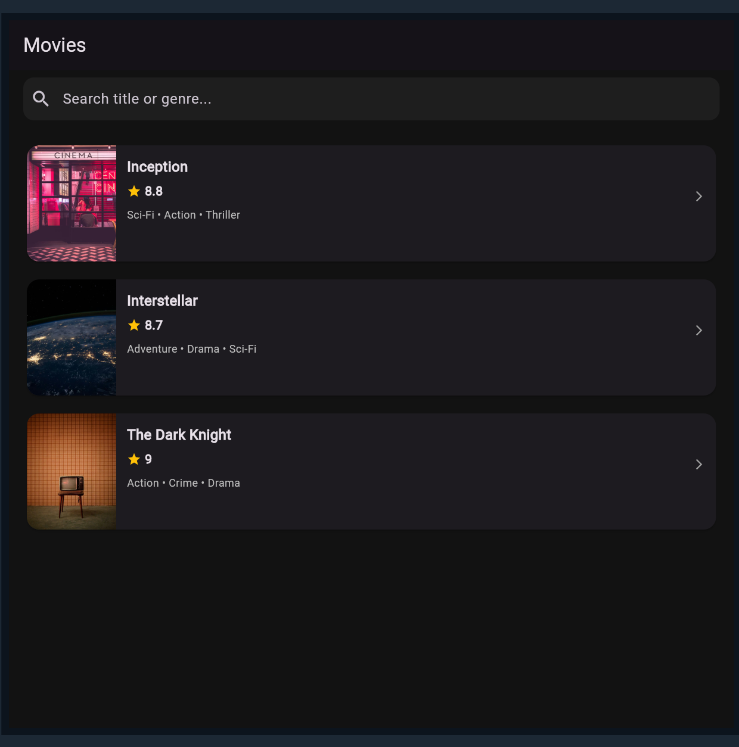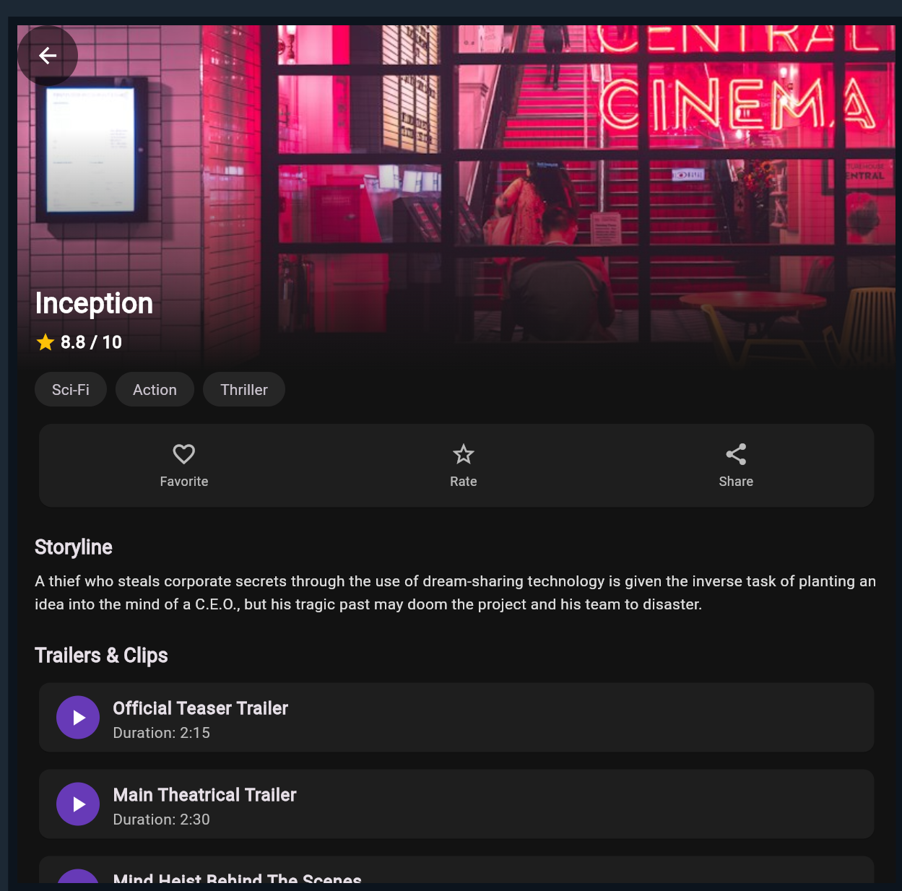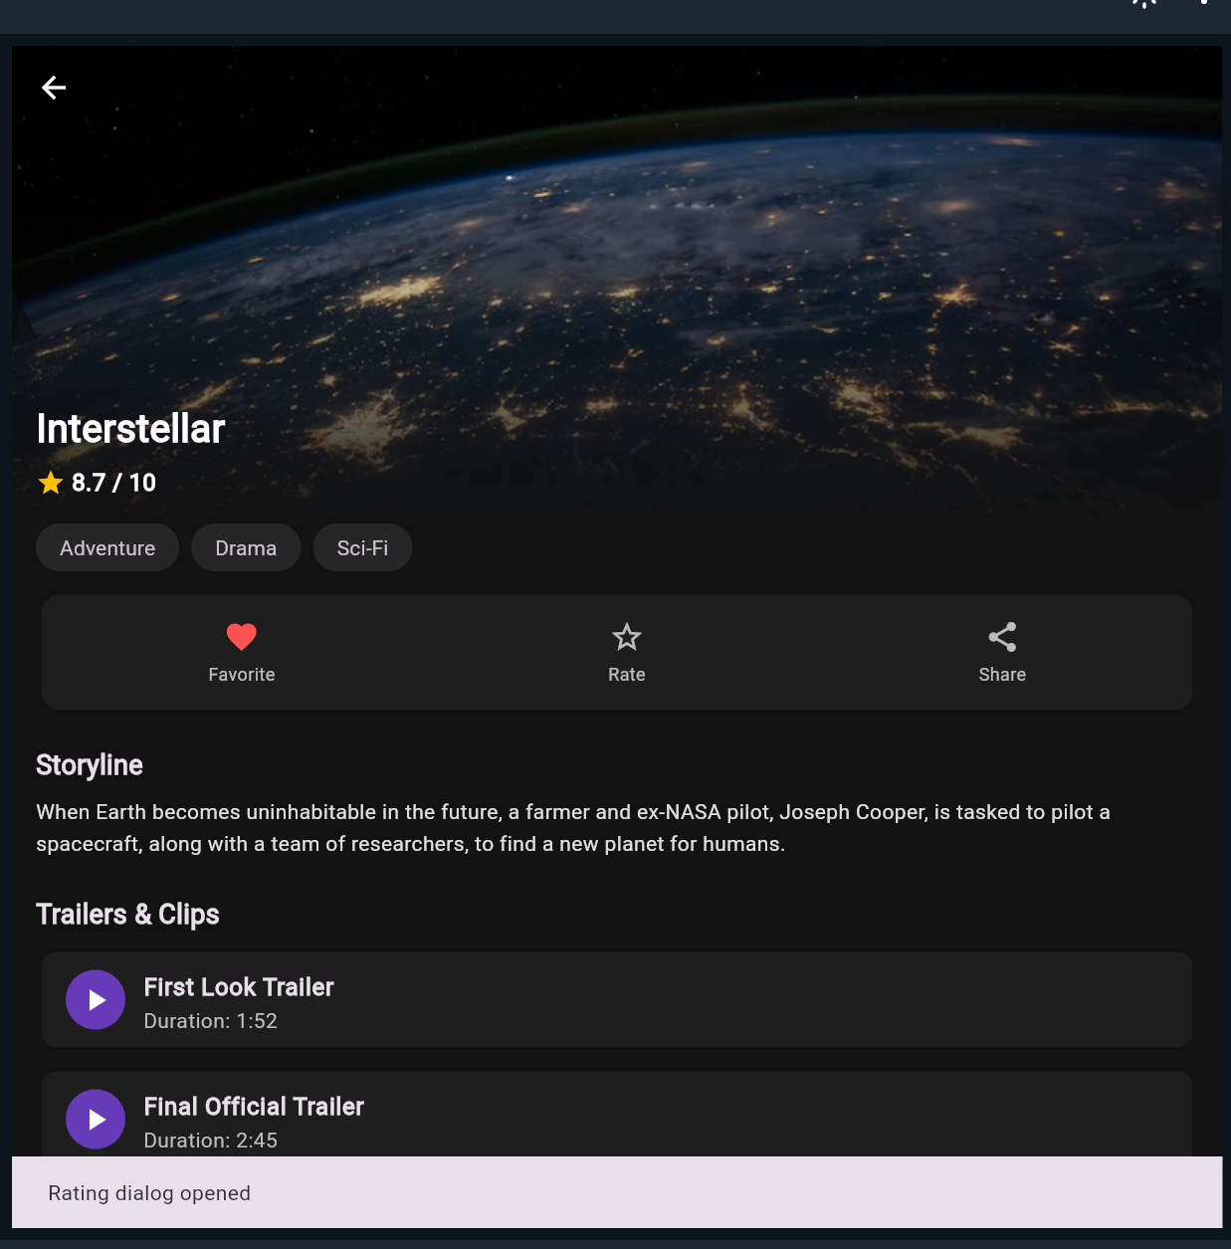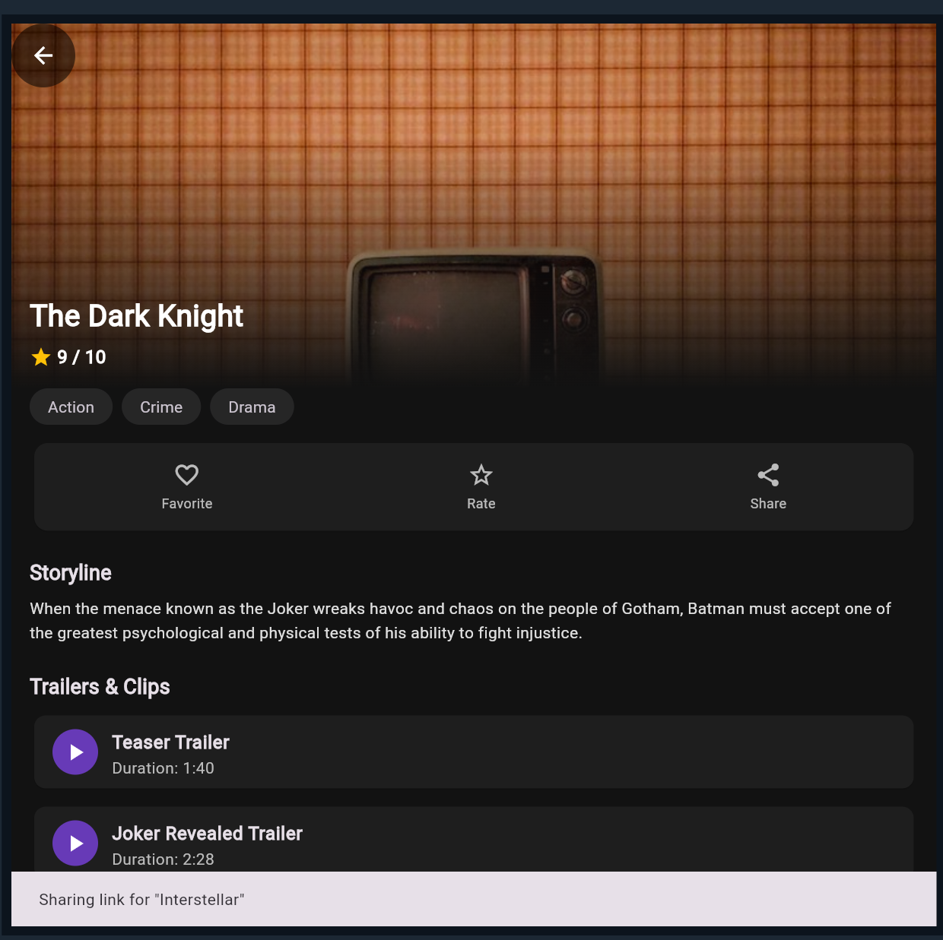
import 'package:flutter/material.dart';

void main() {
runApp(const MovieApp());
}

class MovieApp extends StatelessWidget {
const MovieApp({super.key});

@override
Widget build(BuildContext context) {
return MaterialApp(
title: 'Movie Detail App',
debugShowCheckedModeBanner: false,
theme: ThemeData(
useMaterial3: true,
colorSchemeSeed: Colors.deepPurple,
brightness: Brightness.dark,
scaffoldBackgroundColor: const Color(0xFF121212),
),
home: const HomeScreen(),
);
}
}

// ============================================================================
// STEP 2: DATA MODELS & SAMPLE DATA
// ============================================================================
class Trailer {
final String title;
final String duration;

const Trailer({required this.title, required this.duration});
}

class Movie {
final int id;
final String title;
final String posterUrl;
final String overview;
final List<String> genres;
final double rating;
final List<Trailer> trailers;
bool isFavorite;

Movie({
required this.id,
required this.title,
required this.posterUrl,
required this.overview,
required this.genres,
required this.rating,
required this.trailers,
this.isFavorite = false,
});
}

final List<Movie> sampleMovies = [
Movie(
id: 1,
title: 'Inception',
posterUrl:
'https://images.unsplash.com/photo-1536440136628-849c177e76a1?auto=format&fit=crop&w=800&q=80',
overview:
'A thief who steals corporate secrets through the use of dream-sharing technology is given the inverse task of planting an idea into the mind of a C.E.O., but his tragic past may doom the project and his team to disaster.',
genres: ['Sci-Fi', 'Action', 'Thriller'],
rating: 8.8,
trailers: const [
Trailer(title: 'Official Teaser Trailer', duration: '2:15'),
Trailer(title: 'Main Theatrical Trailer', duration: '2:30'),
Trailer(title: 'Mind Heist Behind The Scenes', duration: '5:40'),
],
),
Movie(
id: 2,
title: 'Interstellar',
posterUrl:
'https://images.unsplash.com/photo-1451187580459-43490279c0fa?auto=format&fit=crop&w=800&q=80',
overview:
'When Earth becomes uninhabitable in the future, a farmer and ex-NASA pilot, Joseph Cooper, is tasked to pilot a spacecraft, along with a team of researchers, to find a new planet for humans.',
genres: ['Adventure', 'Drama', 'Sci-Fi'],
rating: 8.7,
trailers: const [
Trailer(title: 'First Look Trailer', duration: '1:52'),
Trailer(title: 'Final Official Trailer', duration: '2:45'),
],
),
Movie(
id: 3,
title: 'The Dark Knight',
posterUrl:
'https://images.unsplash.com/photo-1509281373149-e957c6296406?auto=format&fit=crop&w=800&q=80',
overview:
'When the menace known as the Joker wreaks havoc and chaos on the people of Gotham, Batman must accept one of the greatest psychological and physical tests of his ability to fight injustice.',
genres: ['Action', 'Crime', 'Drama'],
rating: 9.0,
trailers: const [
Trailer(title: 'Teaser Trailer', duration: '1:40'),
Trailer(title: 'Joker Revealed Trailer', duration: '2:28'),
],
),
];

// ============================================================================
// STEP 3: HOME SCREEN (Movie List + Search Filter)
// ============================================================================
class HomeScreen extends StatefulWidget {
const HomeScreen({super.key});

@override
State<HomeScreen> createState() => _HomeScreenState();
}

class _HomeScreenState extends State<HomeScreen> {
String _searchQuery = '';

@override
Widget build(BuildContext context) {
final filteredMovies = sampleMovies.where((movie) {
return movie.title.toLowerCase().contains(_searchQuery.toLowerCase()) ||
movie.genres.any((g) => g.toLowerCase().contains(_searchQuery.toLowerCase()));
}).toList();

return Scaffold(
appBar: AppBar(
title: const Text('Movies'),
centerTitle: false,
),
body: Column(
children: [
// Optional enhancement: Search Bar
Padding(
padding: const EdgeInsets.symmetric(horizontal: 16.0, vertical: 8.0),
child: TextField(
decoration: InputDecoration(
hintText: 'Search title or genre...',
prefixIcon: const Icon(Icons.search),
filled: true,
fillColor: const Color(0xFF1E1E1E),
border: OutlineInputBorder(
borderRadius: BorderRadius.circular(12),
borderSide: BorderSide.none,
),
),
onChanged: (query) => setState(() => _searchQuery = query),
),
),

// Scrollable Movie List
Expanded(
child: ListView.separated(
padding: const EdgeInsets.all(16),
itemCount: filteredMovies.length,
separatorBuilder: (_, __) => const SizedBox(height: 12),
itemBuilder: (context, index) {
final movie = filteredMovies[index];
return MovieCard(
movie: movie,
onTap: () async {
// Navigate to Movie Detail Screen, passing the Movie object
await Navigator.push(
context,
MaterialPageRoute(
builder: (_) => MovieDetailScreen(movie: movie),
),
);
// Refresh in case favorite status was toggled
setState(() {});
},
);
},
),
),
],
),
);
}
}

class MovieCard extends StatelessWidget {
final Movie movie;
final VoidCallback onTap;

const MovieCard({super.key, required this.movie, required this.onTap});

@override
Widget build(BuildContext context) {
return Card(
elevation: 2,
shape: RoundedRectangleBorder(borderRadius: BorderRadius.circular(14)),
clipBehavior: Clip.antiAlias,
child: InkWell(
onTap: onTap,
child: Row(
crossAxisAlignment: CrossAxisAlignment.start,
children: [
// Poster thumbnail with Hero tag
Hero(
tag: 'movie-poster-${movie.id}',
child: Image.network(
movie.posterUrl,
width: 100,
height: 130,
fit: BoxFit.cover,
errorBuilder: (_, __, ___) => Container(
width: 100,
height: 130,
color: Colors.grey[800],
child: const Icon(Icons.movie, size: 36),
),
),
),
// Movie info
Expanded(
child: Padding(
padding: const EdgeInsets.all(12.0),
child: Column(
crossAxisAlignment: CrossAxisAlignment.start,
children: [
Row(
mainAxisAlignment: MainAxisAlignment.spaceBetween,
children: [
Expanded(
child: Text(
movie.title,
style: const TextStyle(
fontSize: 16,
fontWeight: FontWeight.bold,
),
maxLines: 1,
overflow: TextOverflow.ellipsis,
),
),
if (movie.isFavorite)
const Icon(Icons.favorite, color: Colors.redAccent, size: 18),
],
),
const SizedBox(height: 6),
Row(
children: [
const Icon(Icons.star, color: Colors.amber, size: 16),
const SizedBox(width: 4),
Text(
movie.rating.toString(),
style: const TextStyle(fontWeight: FontWeight.w600),
),
],
),
const SizedBox(height: 8),
Text(
movie.genres.join(' • '),
style: TextStyle(
fontSize: 12,
color: Colors.grey[400],
),
),
],
),
),
),
const Padding(
padding: EdgeInsets.only(top: 50, right: 12),
child: Icon(Icons.arrow_forward_ios, size: 14, color: Colors.grey),
),
],
),
),
);
}
}

// ============================================================================
// STEP 4: MOVIE DETAIL SCREEN
// ============================================================================
class MovieDetailScreen extends StatefulWidget {
final Movie movie;

const MovieDetailScreen({super.key, required this.movie});

@override
State<MovieDetailScreen> createState() => _MovieDetailScreenState();
}

class _MovieDetailScreenState extends State<MovieDetailScreen> {
late bool _isFavorite;

@override
void initState() {
super.initState();
_isFavorite = widget.movie.isFavorite;
}

void _toggleFavorite() {
setState(() {
_isFavorite = !_isFavorite;
widget.movie.isFavorite = _isFavorite; // persist in sample state
});

ScaffoldMessenger.of(context).showSnackBar(
SnackBar(
content: Text(
_isFavorite ? 'Added to favorites!' : 'Removed from favorites.',
),
duration: const Duration(seconds: 1),
),
);
}

@override
Widget build(BuildContext context) {
final movie = widget.movie;

return Scaffold(
extendBodyBehindAppBar: true,
appBar: AppBar(
backgroundColor: Colors.transparent,
elevation: 0,
leading: CircleAvatar(
backgroundColor: Colors.black54,
child: IconButton(
icon: const Icon(Icons.arrow_back, color: Colors.white),
onPressed: () => Navigator.pop(context),
),
),
),
body: SingleChildScrollView(
child: Column(
crossAxisAlignment: CrossAxisAlignment.start,
children: [
// 1. Hero Banner (Stack + Image.network + Gradient)
Stack(
alignment: Alignment.bottomLeft,
children: [
Hero(
tag: 'movie-poster-${movie.id}',
child: Image.network(
movie.posterUrl,
height: 320,
width: double.infinity,
fit: BoxFit.cover,
errorBuilder: (_, __, ___) => Container(
height: 320,
color: Colors.grey[900],
child: const Center(child: Icon(Icons.movie, size: 60)),
),
),
),
// Gradient overlay
Container(
height: 320,
decoration: const BoxDecoration(
gradient: LinearGradient(
begin: Alignment.topCenter,
end: Alignment.bottomCenter,
colors: [
Colors.transparent,
Color(0x88121212),
Color(0xFF121212),
],
stops: [0.3, 0.7, 1.0],
),
),
),
// Title and Rating on top of the banner bottom
Padding(
padding: const EdgeInsets.all(16.0),
child: Column(
crossAxisAlignment: CrossAxisAlignment.start,
children: [
Text(
movie.title,
style: const TextStyle(
fontSize: 26,
fontWeight: FontWeight.bold,
color: Colors.white,
),
),
const SizedBox(height: 6),
Row(
children: [
const Icon(Icons.star, color: Colors.amber, size: 20),
const SizedBox(width: 4),
Text(
'${movie.rating} / 10',
style: const TextStyle(
fontSize: 16,
fontWeight: FontWeight.bold,
color: Colors.white,
),
),
],
),
],
),
),
],
),

// 2. Genres displayed as Chips (Wrap + Chip)
Padding(
padding: const EdgeInsets.symmetric(horizontal: 16.0),
child: Wrap(
spacing: 8.0,
children: movie.genres.map((genre) {
return Chip(
label: Text(genre),
backgroundColor: const Color(0xFF262626),
side: BorderSide.none,
shape: RoundedRectangleBorder(
borderRadius: BorderRadius.circular(16),
),
);
}).toList(),
),
),
const SizedBox(height: 12),

// 3. Action Buttons (Favorite / Rate / Share)
Padding(
padding: const EdgeInsets.symmetric(horizontal: 16.0),
child: Card(
color: const Color(0xFF1E1E1E),
shape: RoundedRectangleBorder(borderRadius: BorderRadius.circular(12)),
child: Padding(
padding: const EdgeInsets.symmetric(vertical: 8.0),
child: Row(
mainAxisAlignment: MainAxisAlignment.spaceAround,
children: [
_buildActionButton(
icon: _isFavorite ? Icons.favorite : Icons.favorite_border,
color: _isFavorite ? Colors.redAccent : Colors.white70,
label: 'Favorite',
onTap: _toggleFavorite,
),
_buildActionButton(
icon: Icons.star_border,
color: Colors.white70,
label: 'Rate',
onTap: () {
ScaffoldMessenger.of(context).showSnackBar(
const SnackBar(content: Text('Rating dialog opened')),
);
},
),
_buildActionButton(
icon: Icons.share,
color: Colors.white70,
label: 'Share',
onTap: () {
ScaffoldMessenger.of(context).showSnackBar(
SnackBar(content: Text('Sharing link for "${movie.title}"')),
);
},
),
],
),
),
),
),
const SizedBox(height: 20),

// 4. Overview text
const Padding(
padding: EdgeInsets.symmetric(horizontal: 16.0),
child: Text(
'Storyline',
style: TextStyle(fontSize: 18, fontWeight: FontWeight.bold),
),
),
const SizedBox(height: 8),
Padding(
padding: const EdgeInsets.symmetric(horizontal: 16.0),
child: Text(
movie.overview,
style: TextStyle(
fontSize: 14,
height: 1.5,
color: Colors.grey[300],
),
),
),
const SizedBox(height: 24),

// 5. Trailers List
const Padding(
padding: EdgeInsets.symmetric(horizontal: 16.0),
child: Text(
'Trailers & Clips',
style: TextStyle(fontSize: 18, fontWeight: FontWeight.bold),
),
),
const SizedBox(height: 8),
ListView.separated(
shrinkWrap: true,
physics: const NeverScrollableScrollPhysics(),
padding: const EdgeInsets.symmetric(horizontal: 16.0),
itemCount: movie.trailers.length,
separatorBuilder: (_, __) => const SizedBox(height: 8),
itemBuilder: (context, index) {
final trailer = movie.trailers[index];
return Card(
color: const Color(0xFF1E1E1E),
shape: RoundedRectangleBorder(
borderRadius: BorderRadius.circular(10),
),
child: ListTile(
leading: const CircleAvatar(
backgroundColor: Colors.deepPurple,
child: Icon(Icons.play_arrow, color: Colors.white),
),
title: Text(
trailer.title,
style: const TextStyle(fontWeight: FontWeight.w600),
),
subtitle: Text(
'Duration: ${trailer.duration}',
style: TextStyle(color: Colors.grey[400]),
),
onTap: () {
ScaffoldMessenger.of(context).showSnackBar(
SnackBar(content: Text('Playing: ${trailer.title}')),
);
},
),
);
},
),
const SizedBox(height: 32),
],
),
),
);
}

Widget _buildActionButton({
required IconData icon,
required Color color,
required String label,
required VoidCallback onTap,
}) {
return InkWell(
onTap: onTap,
borderRadius: BorderRadius.circular(8),
child: Padding(
padding: const EdgeInsets.all(8.0),
child: Column(
children: [
Icon(icon, color: color, size: 24),
const SizedBox(height: 4),
Text(label, style: const TextStyle(fontSize: 12, color: Colors.white70)),
],
),
),
);
}
}

